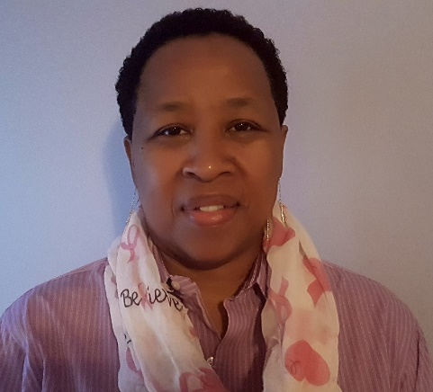
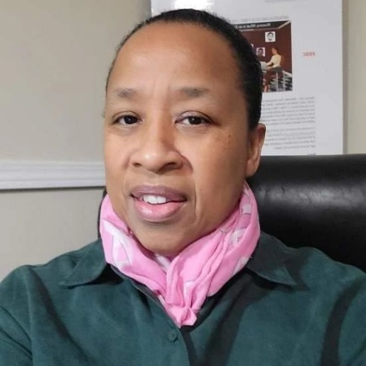
Bio:
When Computer Technical Instructor/Tech Writer; Michelle Cox aka Michelle, The Computer Lady was diagnosed with breast cancer at age 55, she did not give up or fall into a depression. Instead, she turned the diagnosis into a wakeup call to pursue her dream to make a difference as a children’s book author.
Michelle started; ML Cox Media LLC publishing company for her books with the hopes of igniting a love of reading and technology in children at a young age.

Michelle The Computer Lady:
She creates STEM inspired Children’s books as an Author/Publisher. Penning, The Mommy Readers Collection series for children ages 5 to 12. These books are about smart Mommies who teach their Children about (STEM) Science, Technology, Engineering and Math in a picture book format.

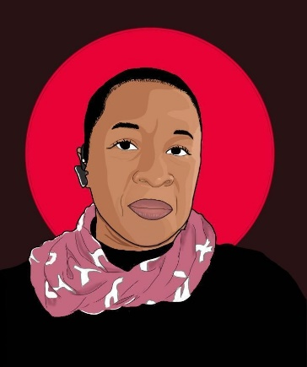
Michelle is a Distinguished Authors Guild award winning author for her Children’s eBook, titled: “Mommy, What is an Entrepreneur?” This book teaches children about Entrepreneurship and Entrepreneurs in our world. Her first book,” Mommy, is the Computer Smarter than Me?”; was an Independent Publishers book award nominee. She created this book to help children understand the role of Computers and how we as humans are much smarter than technology in many ways.
Michelle, The Computer Lady got her name as a Computer Support Analyst/Specialists for over 25+ years, serving multiple I.T. (Information Technology) accounts repairing, PCs, Workstations, Desktops, Laptops, Servers, Routers, Storage Arrays and Point of Sales equipment for corporate clients. She is an instructor, teaching computer hardware repair and entrepreneurship at CellBotics Performance Training Center in Atlanta, GA.
What’s New:
Michelle’s company ML Cox Media LLC is committed to be the new face of modern business. She states: ML Cox Media LLC is a for profit company with the purpose of working towards the greater good. Within this purpose over profit model, she has created; the Building Towards Our Future fundraiser for Grady Hospital.
Michelle said, Grady saved my life and my mission is to make sure that Grady Hospital will always be around to serve the poor and underserved in our community. This need is greater than ever with the closing of WellStar AMC in November 2022.
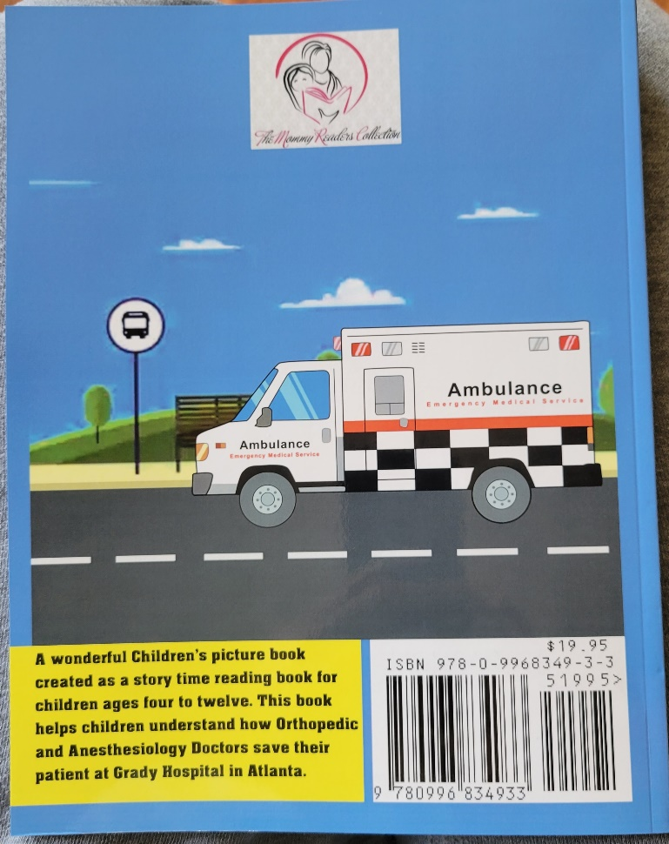
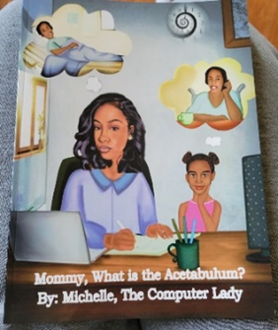
Michelle, The Computer Lady has written a new book and it has been nominated for a Distinguished Authors Guild award. The book is titled; “Mommy, What is the Acetabulum?” With this new book, we are looking to raise 90 million dollars for Grady. Our launch and pre-order date will be mid November 2022. Look for more information on our website.

Social Media Links:
https://www.instagram.com/michelle_tcl1
https://www.linkedin.com/in/michelle-cox-20875014
https://10000cards.com/card/michelle-cox
https://www.facebook.com/themommyreaderscollection/
https://www.youtube.com/watch?v=woBVfGAkGms&t=60s
https://www.pinterest.com/Michelle_TCL/childrens-book-author-publisher/

Interviews:
http://selfpublishersshowcase.com/michelle-the-computer-lady/
https://www.blogtalkradio.com/wordofmomradio/2020/03/25/the-computer-lady-michelle-cox-joins-us-in-the-authors-alley-on-womradio
https://www.theindiebook.store/product_author/the-computer-lady-cox/
https://cellbotics.com/computer-repair-training-why/

Press releases:
http://www.releasewire.com/press-releases/free-ebook-for-kids-to-celebrate-4-years-of-beating-breast-cancer-1266749.htm
https://youtu.be/AT-zwuvowBE
https://www.glartent.com/US/Bethlehem/1654227321532324/The-Mommy-Readers-Collection
https://twitter.com/Michelle_TCL1/status/1248647023991144449
https://rockabuy.com.au/themommyreaderscollection/

